**User Manual**

For

Cateina CMS Portal

|  |  |
| --- | --- |
| Version No: | 1.0.0 |
| Release Date: | 14th July 2018 |

Prepared By – Rushikesh Mokashi, Srihari Nair, Suchit Gupta, Manjyot Singh Nanra



All rights reserved. The copyright in this work vests with Cateina Technologies Pvt Ltd (hereinafter referred as Cateina). No part of this work, can be reproduced,

stored in whole or in part, or transmitted in any form or by any means of electronic, mechanical, photocopying or otherwise, or used or disclosed without the prior

express written consent of Cateina.

Table of Contents

1.Introduction

2.Login and Signup

3.Forget Password

4.Admin

5.Pages

Dashboard.

-6. Leaves

-7. Expenses

-8. Posts

-9. Birthday List

-10. Documents

-11. Home

**1.Introduction**

**What is Cateina?**

At Cateina, we build products and solutions that enable reconstruction of legacy business practices and drive growth. Our passion reflects in our work and Customer satisfaction. Our innovation is the first priority, doing what has not been done before is what we aim for, here at Cateina Technologies.

Enterprise Application Integration (EAI)

Cateina's Enterprise Application Integration (EAI) Practice provides the tools enterprises need for connecting cloud and on-premises applications, building microservices and exposing and managing APIs. It enables you to reach new markets, rapidly take advantage of new business opportunities and improve communications within your partner ecosystem

Blockchain Technology (BCT)

Blockchain offers a radical new computing paradigm of decentralized networks challenging conventional processes across industries and society. Cateina’s Blockchain Technology (BCT) Practice and expertise will enable you to explore and navigate the potential of Blockchain and pilot solutions customized to your business needs

**What is the Cateina CMS Portal?**

The Cateina CMS Portal is a portal system for employees in Cateina which can be used to register every employee to communicate with their managers/HRs to apply for leaves, reimburse company expenses, make technical posts, upload their credentials and documents and can check employee birthdays.

Sqlite3 is being used as it database. Users have to signup to their accounts by a relevant login password and the CMS Portal also has features when users forget their password or want to change so if need be. User data can be changed by themselves or the HR/managers.

**2.Login and Signup**

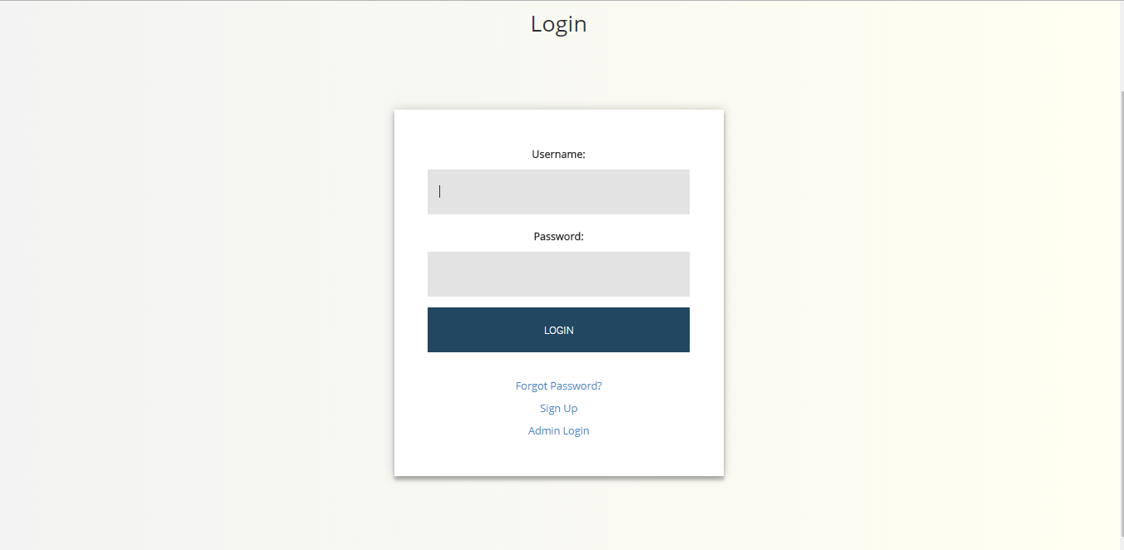

* To log in to the Cateina CMS Portal the user must enter his correct username and password. The user will have to create an account in the CMS Portal by clicking on the **Sign Up** button. New accounts can also be added by the admin.
* If the user has forgotten his password the user can click on the **forgot password** which shall redirect him to the forgot password page.
* The Admin Login is specifically for Cateina admins and they shall have separate administrator privileges

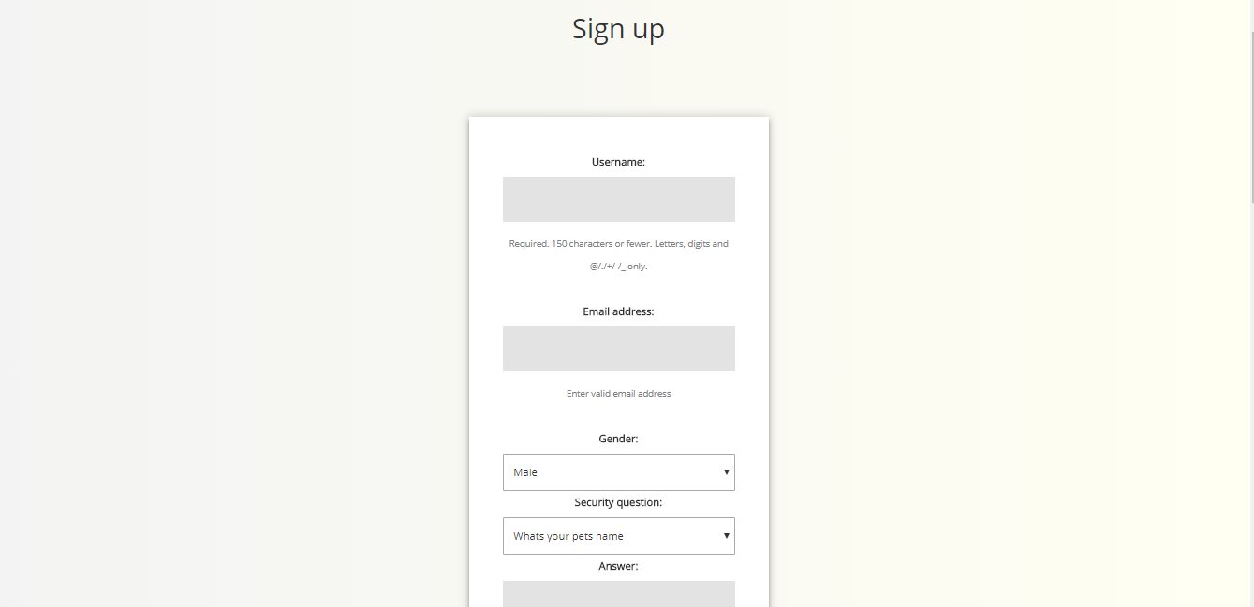

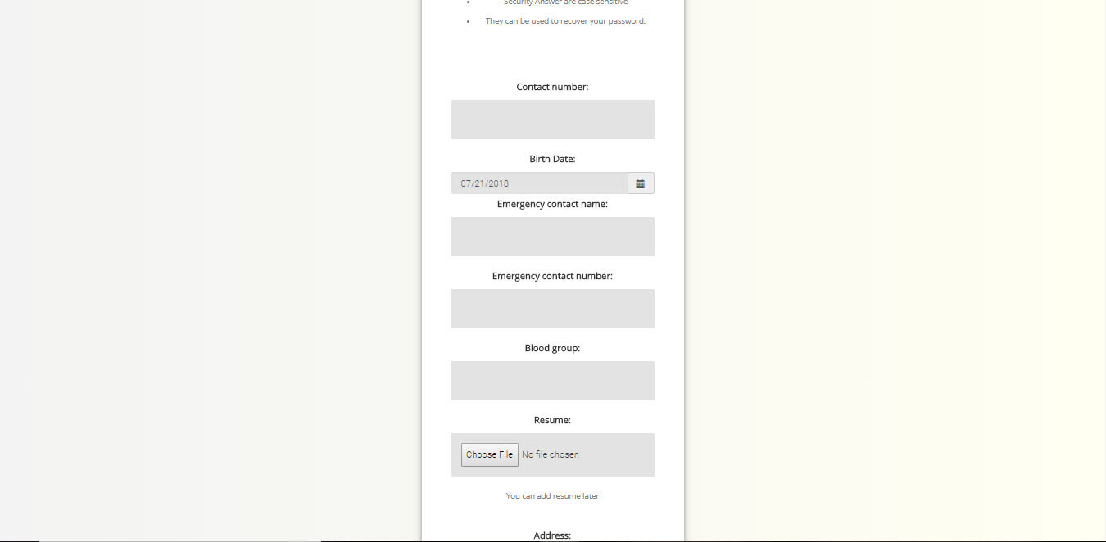

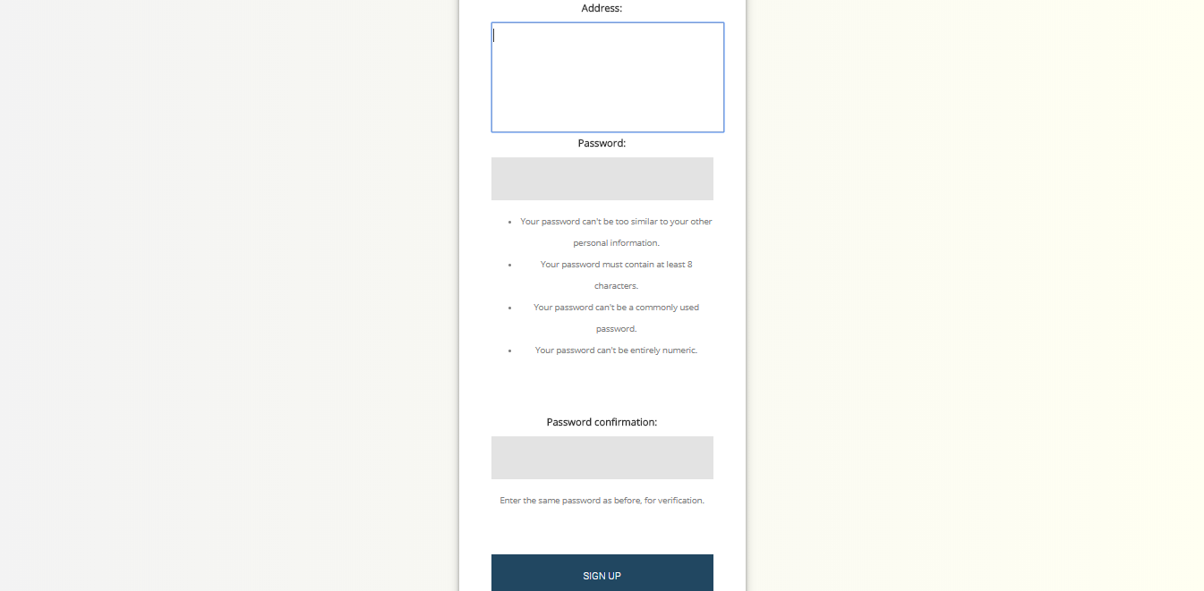

* To Sign up the user will have to enter his **username, email address, gender, security question, answer, Birth date, Resume, Password, Address, Blood Group** and confirm

password.

* Specified rules should be followed while making the password or else on cannot proceed.
* You can click **Login instead?** If you already have an existing account
* Admin accounts cannot be created via this Signup page and have to be created separately

**3.Forget Password**



* The forgot password page shall ask you for your Username first



* You shall be prompted with your security question for which you have to enter the correct answer



* Finally you have to enter your new password and confirm it, after which you shall be prompted back to the login page. Your password has now been changed

**4.Admin**

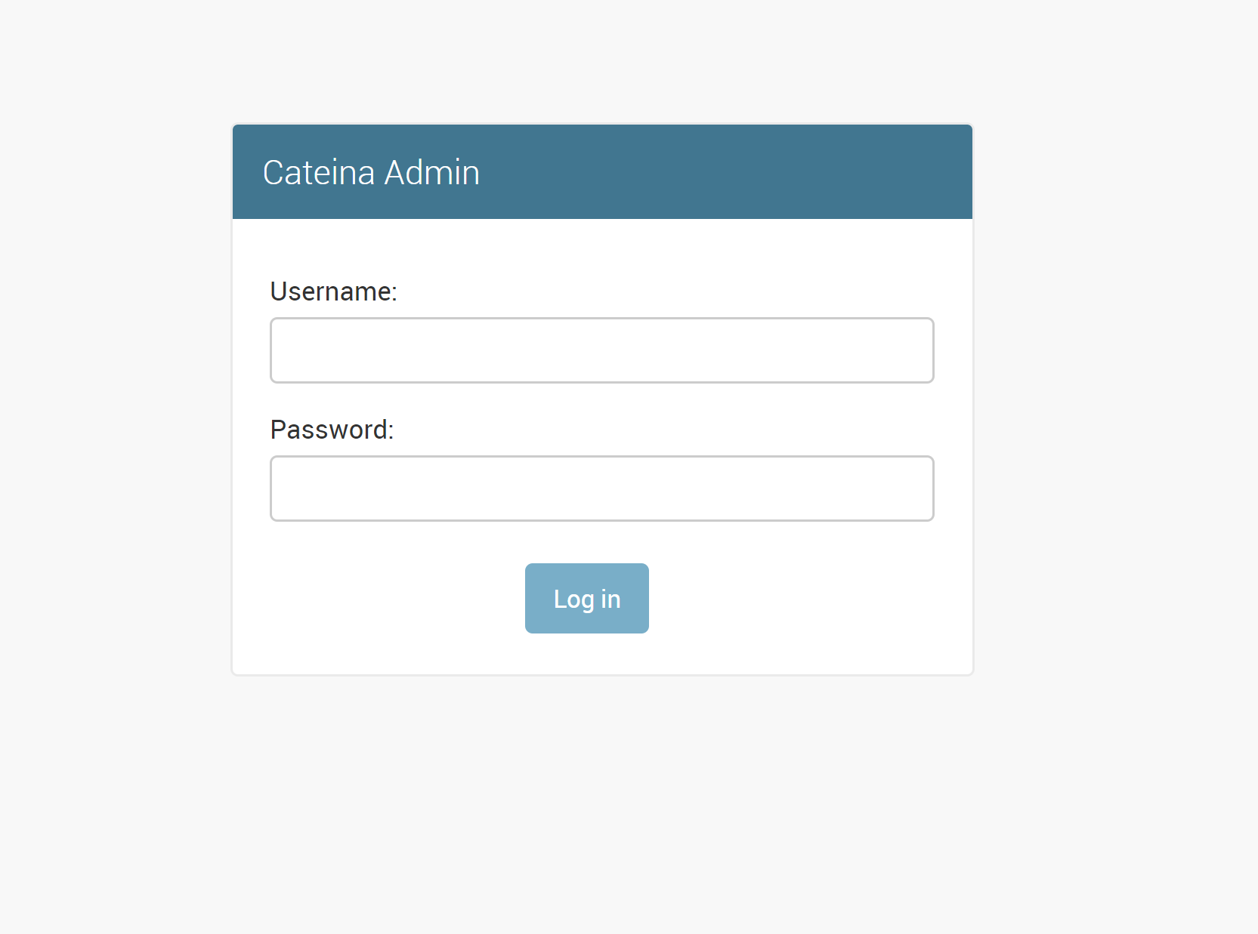

* Admin page only allows Administrator to login. This login provides special privileges to the user to edit and delete models from the portal.
* No new users can be created directly from the page.
* On entering the correct login ID and password the user will be redirected to the admin dashboard.

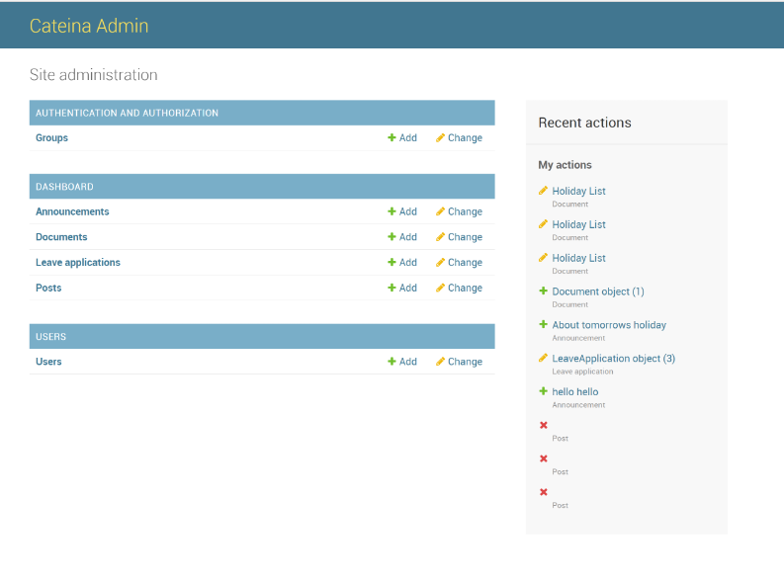

* The user content is divided into different groups on the Dashboard.
* Admin can view all the contents of the portal.
* By clicking on any option, the admin will be redirected to the list of all the content associated with the title.

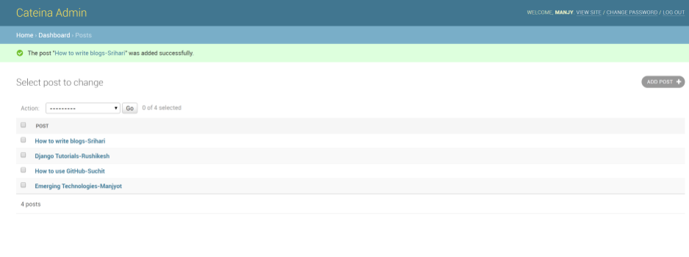

* Admin can edit or delete all the posts.

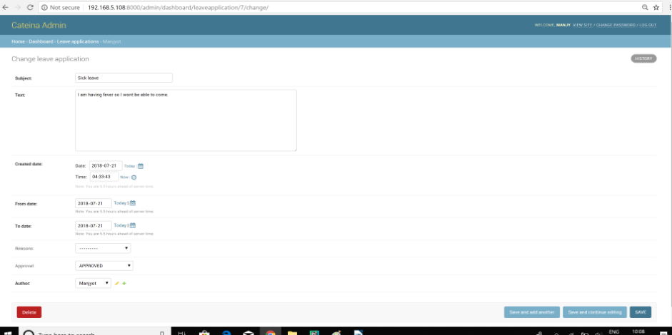

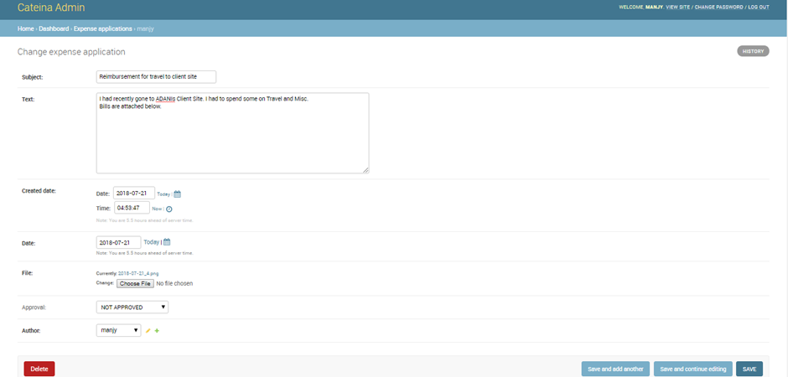

* Admin can view the leave applications and expense reports as well as approve or disapprove them.

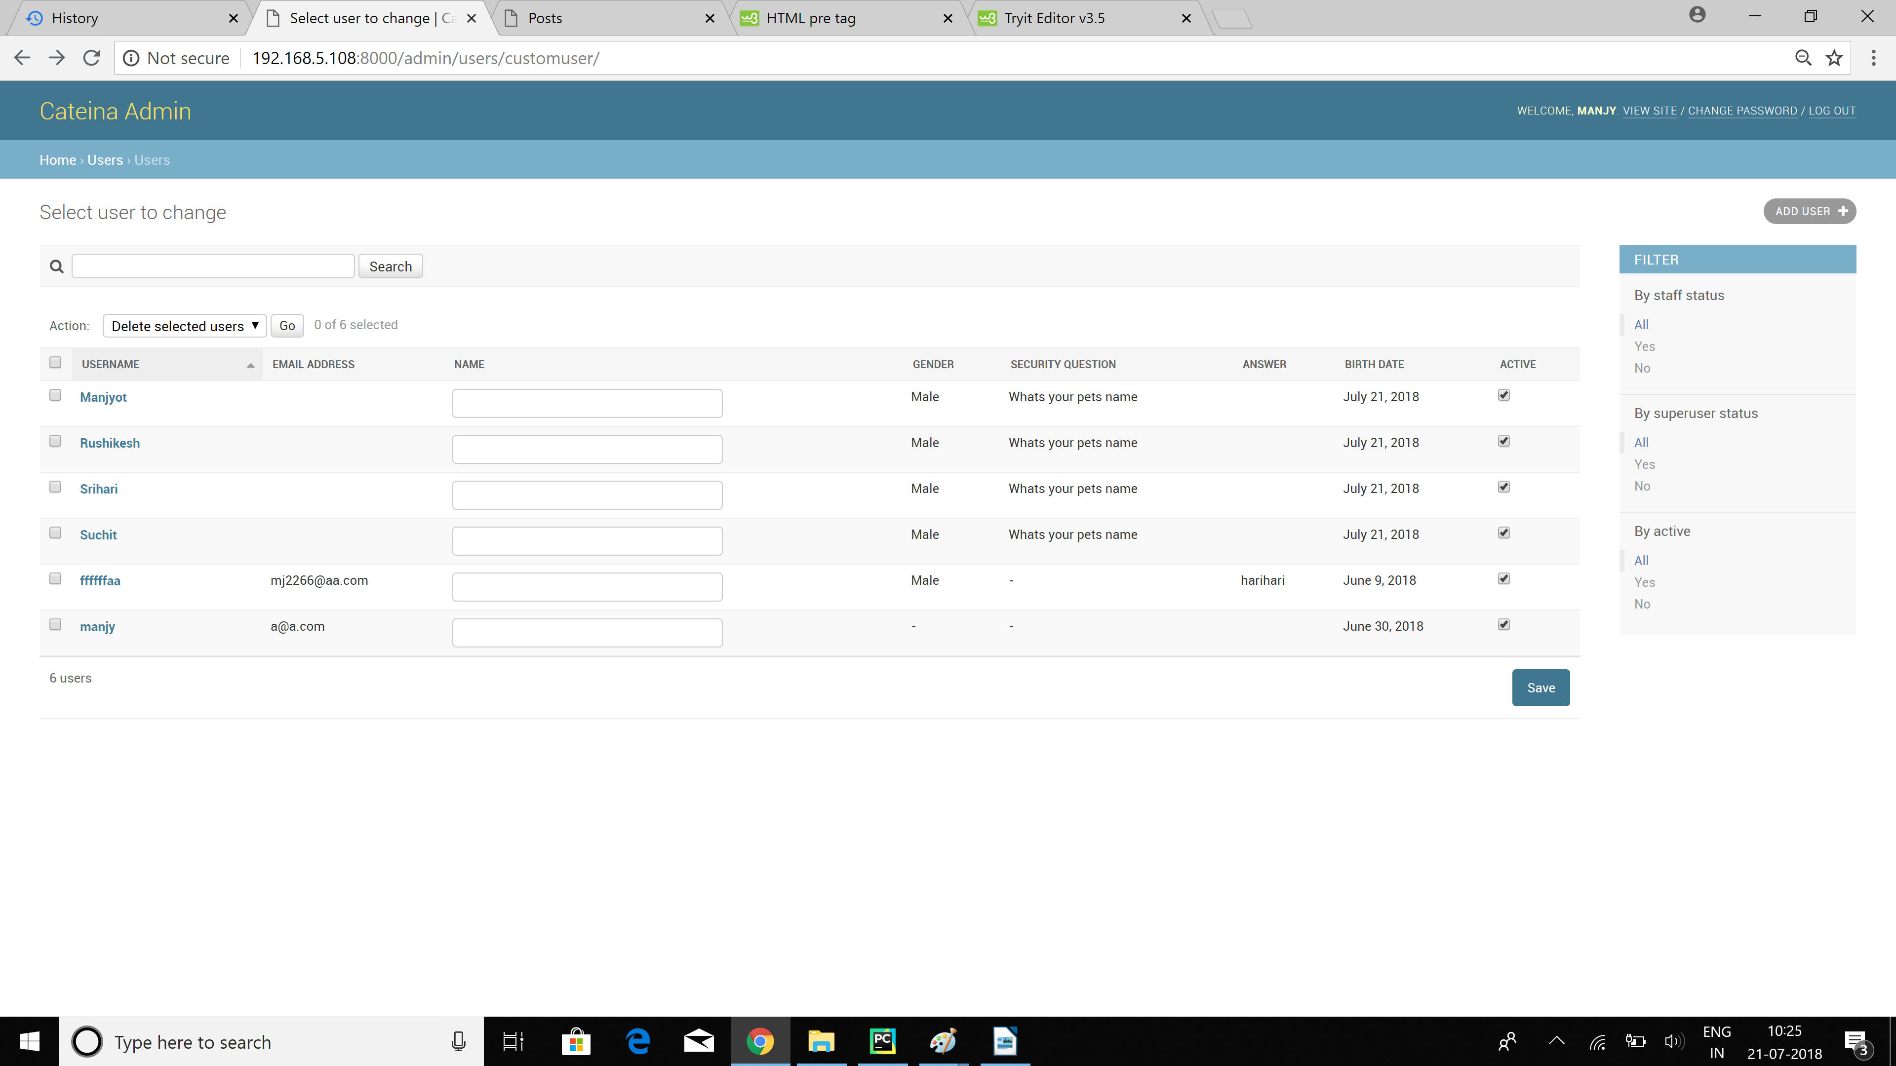

* Admin the see all the users, their details and can edit and delete them too.

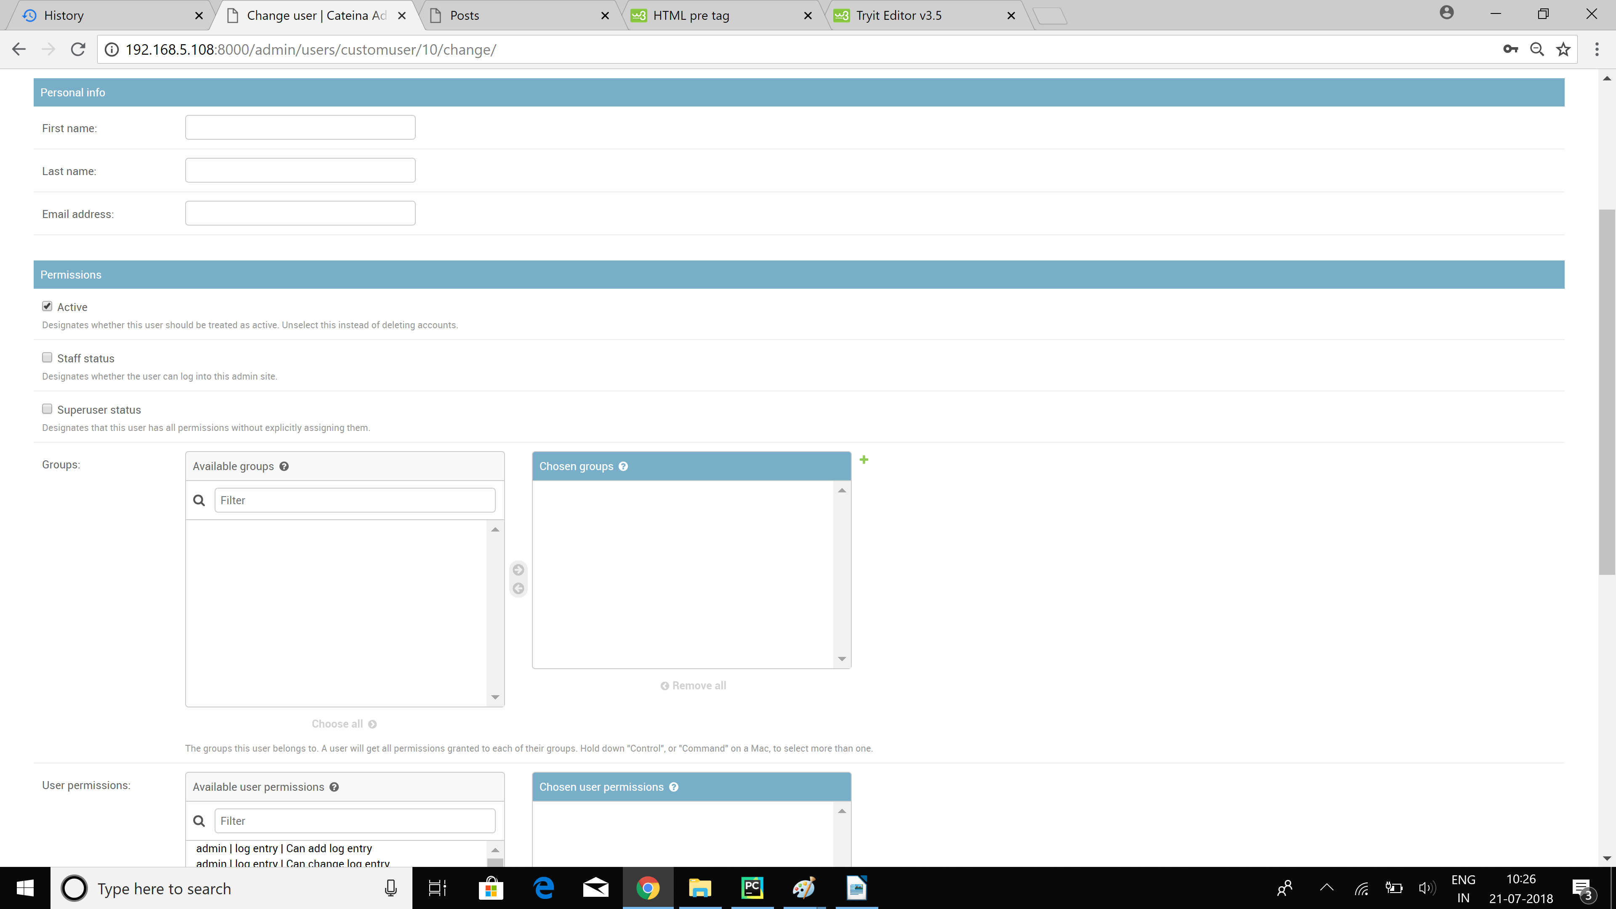

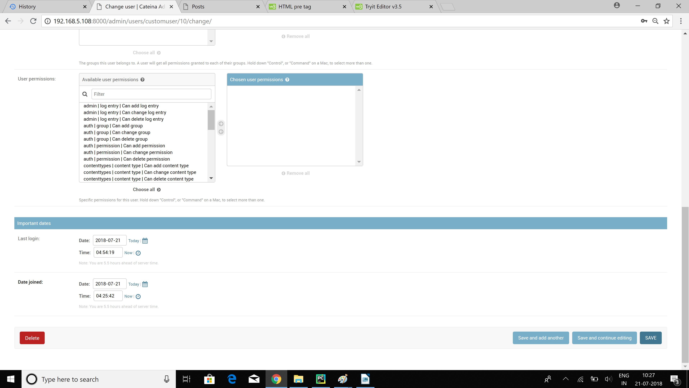

* All the recent actions of the admin are tracked and displaying in the sidebar to the right.
* Admin can change the various permissions given to the user and put him into several groups at a time.

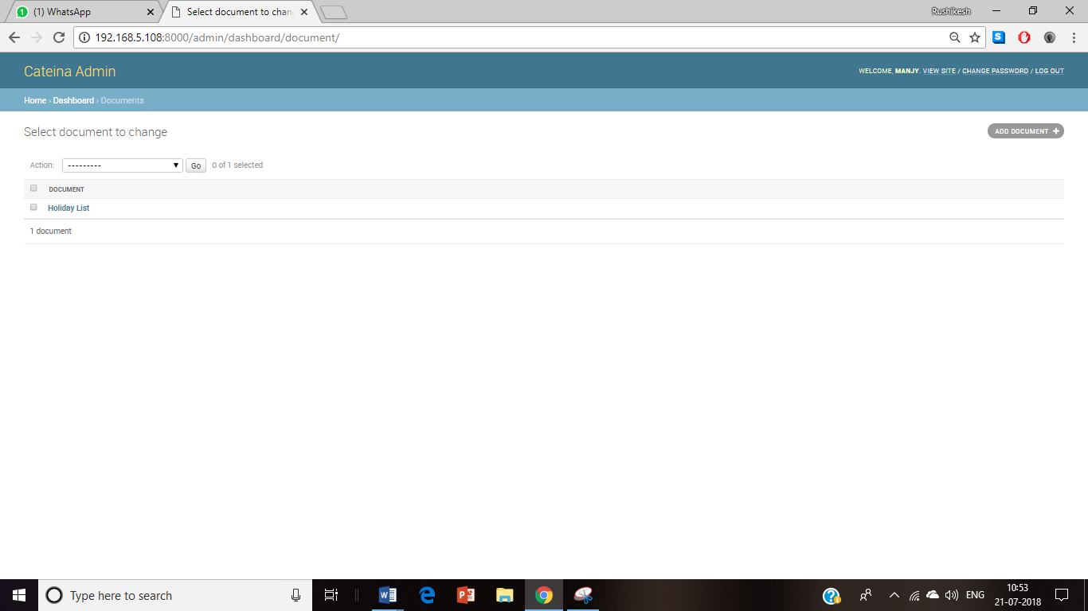

* Admin can add documents like holiday list or company policies in the document section.

**5.Pages**

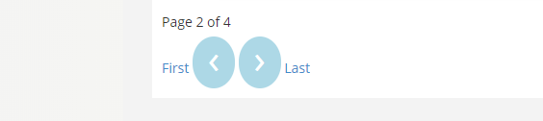

* Pages can be traversed through by using the functionality provided at the end of every page.
* **First/Previous/Next/Last** Buttons can be used provided there exists a page to be redirected to.
* This is present at the bottom of **Posts, Leaves, Expense List.**

**6.Leaves**

* Select the Leaves option from the Dashboard
* On selecting it you will see this screen.
* This is your main page for leave application. You can check whether your leave is approved or not. And you can apply for leaves by clicking on the New Application Button.

Once you click the New Application Button you will be directed to this page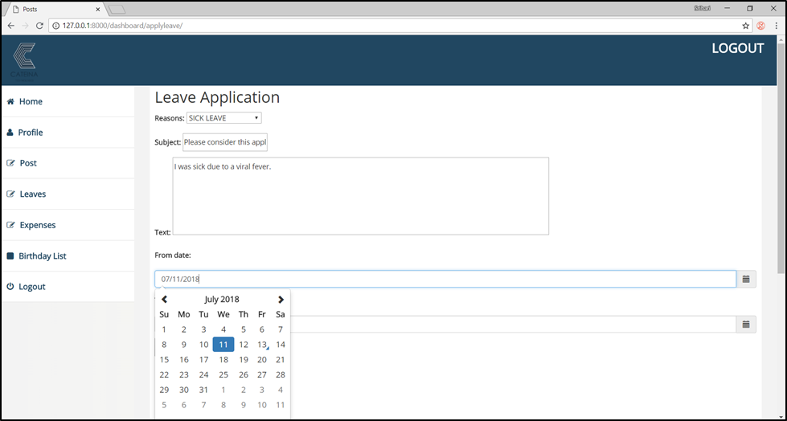

* You will select the :
  + - 1. Reason for leave
      2. Subject
      3. Text
      4. From Date
      5. To Date

and you click Submit.

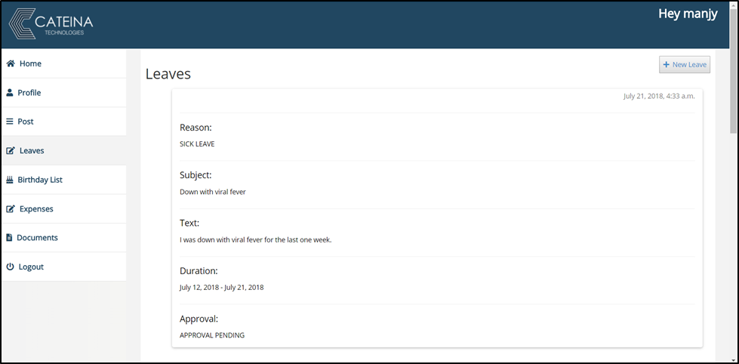

* Doing this will register your Leave Application which will now be Approved or Not Approved by the Admin(HR/Manager).
* Till it is either Approved or Not Approved by the Admin it’ll show APPROVAL PENDING.
* When Approved or Not Approved by the Admin(HR/Manager) you will see the update on the Leaves Page.

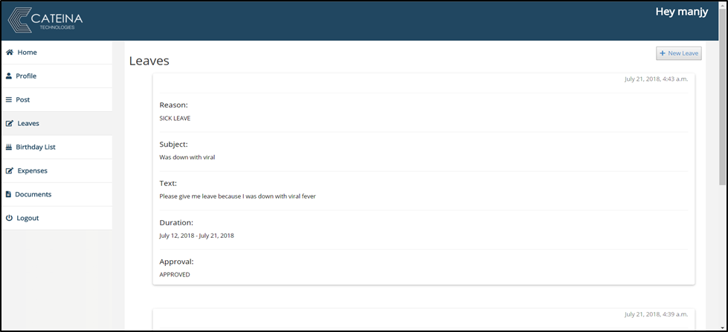

**7.Expenses**

* Select the Expenses option from the Dashboard
* On selecting it you will see this screen.

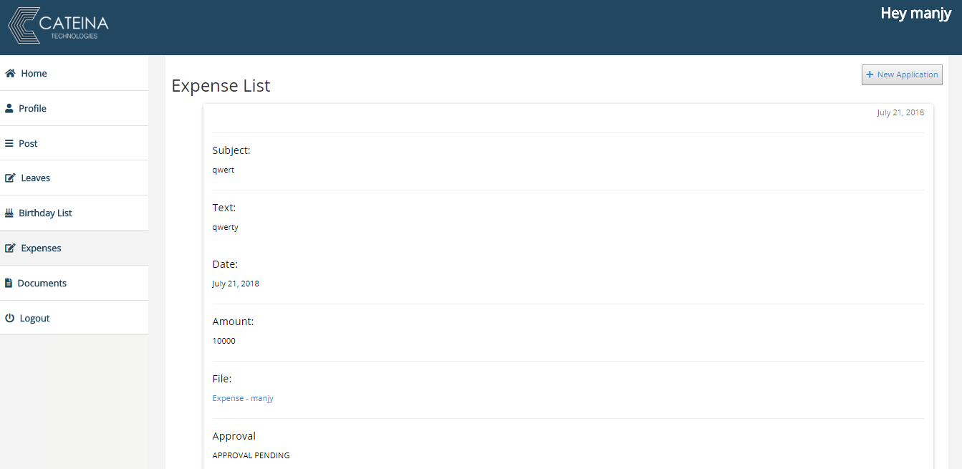

* This is your main page for Expense Application. You can check whether your Expense is approved or not. And you can apply for Expense by clicking on the New Application Button.
* Once you click the New Application Button you will be directed to this page.

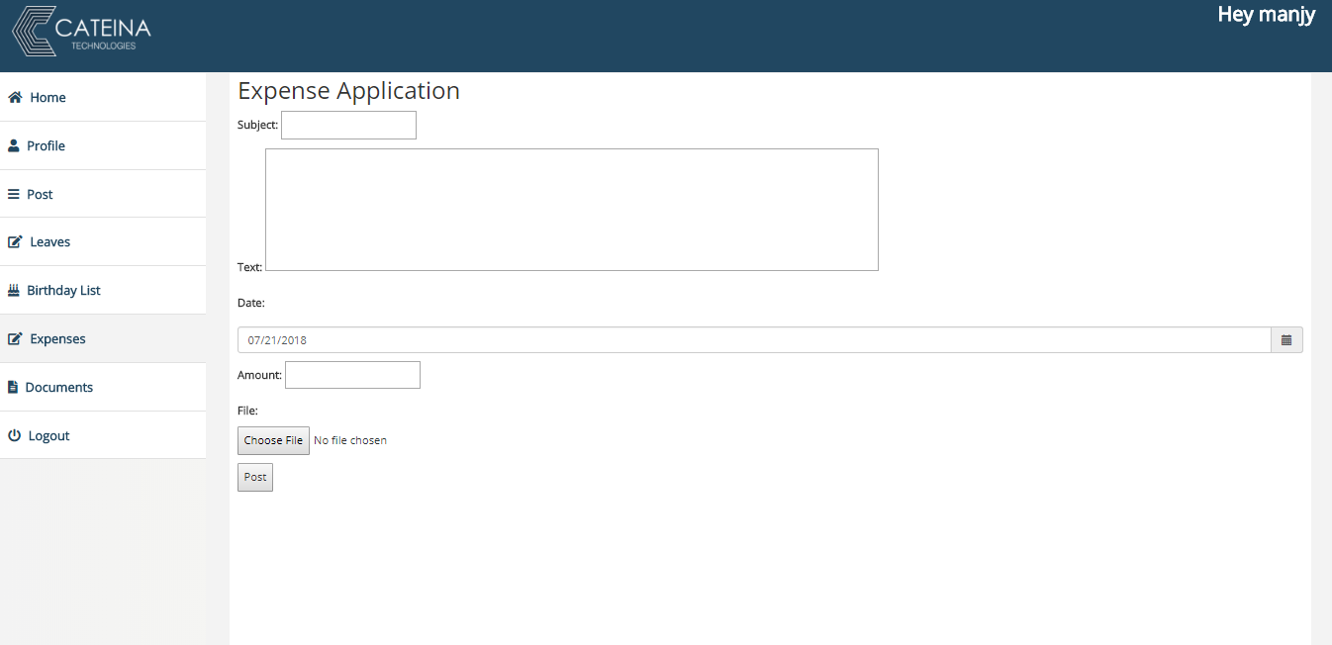

* You will select the:
  + - 1. Subject
      2. Text
      3. Date
      4. Amount
      5. File (Bills for the following Application)

and you click Submit.

* Doing this will register your Expense Application which will now be Approved or Not Approved by the Admin (HR/Manager).
* Till it is either Approved or Not Approved by the Admin it’ll show APPROVAL PENDING.
* When Approved or Not Approved by the Admin (HR/Manager) you will see the update on the Expenses Page.

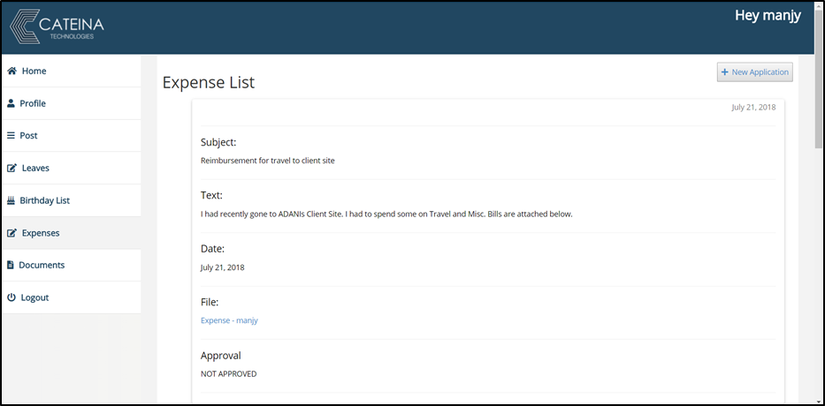

* This page will show the Expense reports by the users and their approval.

**8.Posts**

* Select the Post option from the Dashboard
* On selecting it you will see this screen.

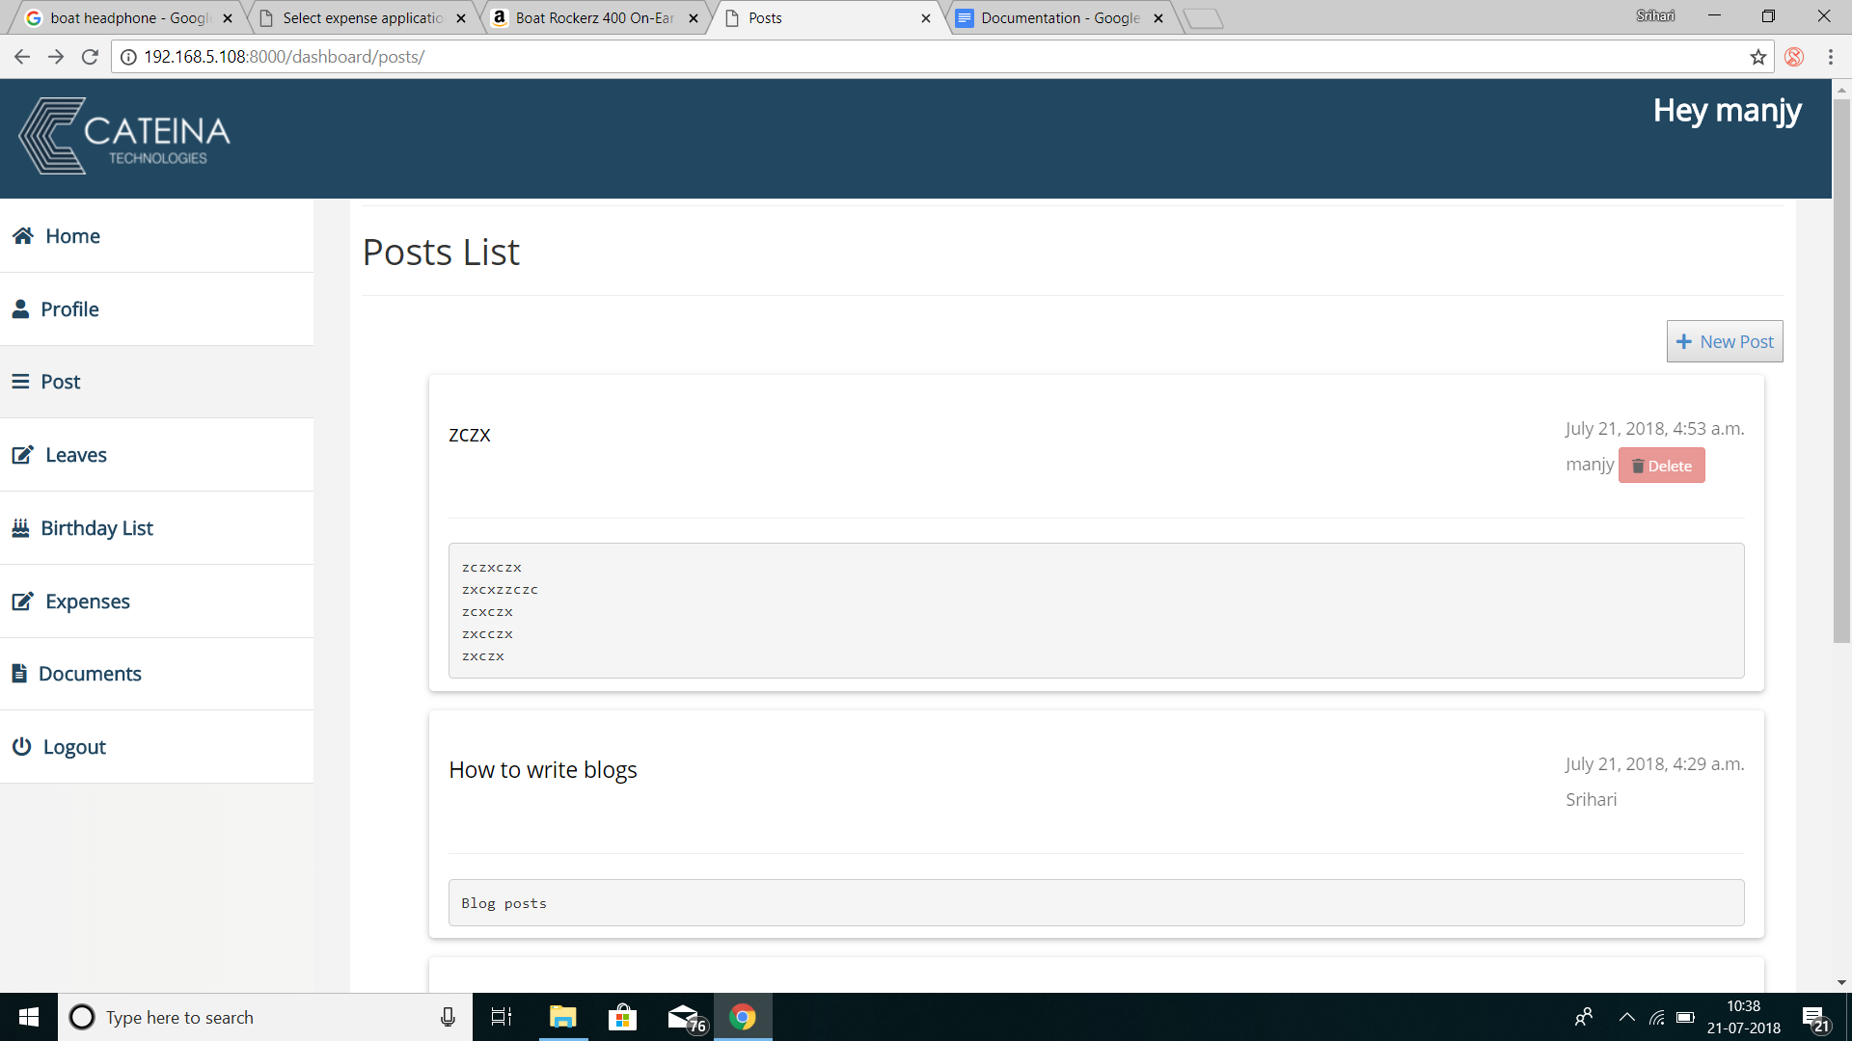

* This is your main page for the Company Blogs. You can Post a new Blog by clicking on the New Post Button.
* Once you click the New Post Button you will be directed to this page.
* You will find a delete button next to the blogs only created by you.

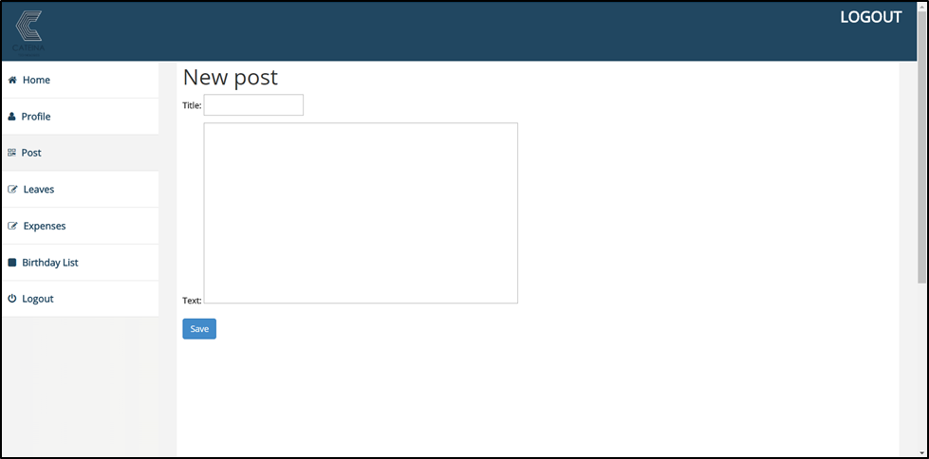

* You will select the :
  + - 1. Title
      2. Text

and you click Save.

* Doing this will register your Post which can now be read by all the Employees using the Portal.
* Any links or URLs you add in your post will automatically be changed into a hyperlink.

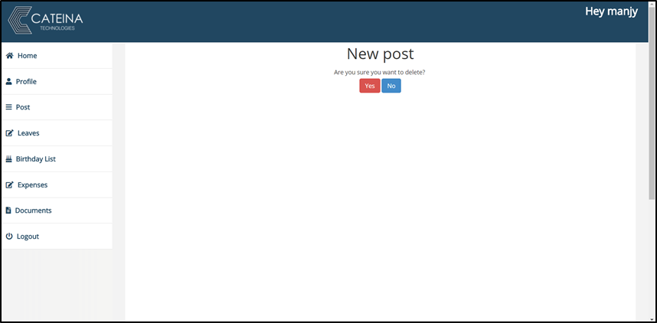

* Once you click on the delete button provided to delete specifically only your blog, you will be directed to this page.
* If you press Yes you successfully delete your blog and if you select No your blog won’t be deleted.
* In any case you will be directed back to the Main Post Page

**9.BIRTHDAY LIST**

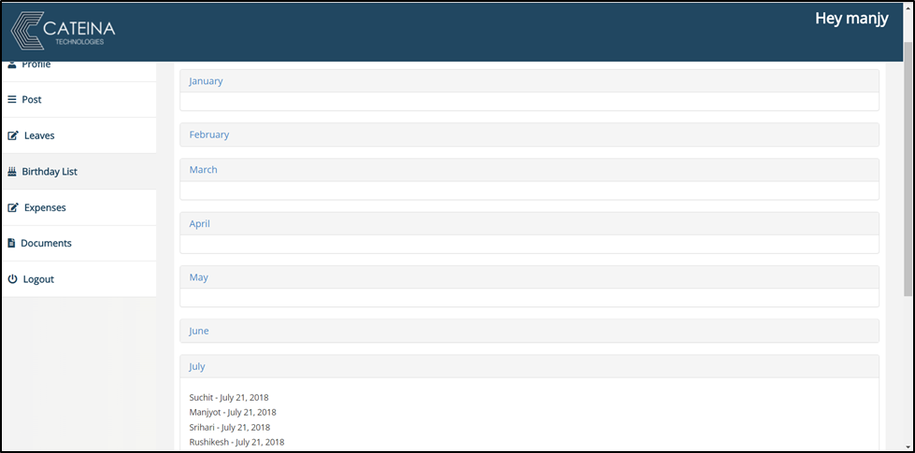

* Select the Birthday List option from the Dashboard
* On selecting it you will see this screen.
* You will see a collapsible List which currently displays the months in an year.
* On clicking on any month you get a list of birthdays which are there in that month.
* Your birthday is directly added to the list when you sign up for the First Time.

**10.Documents**

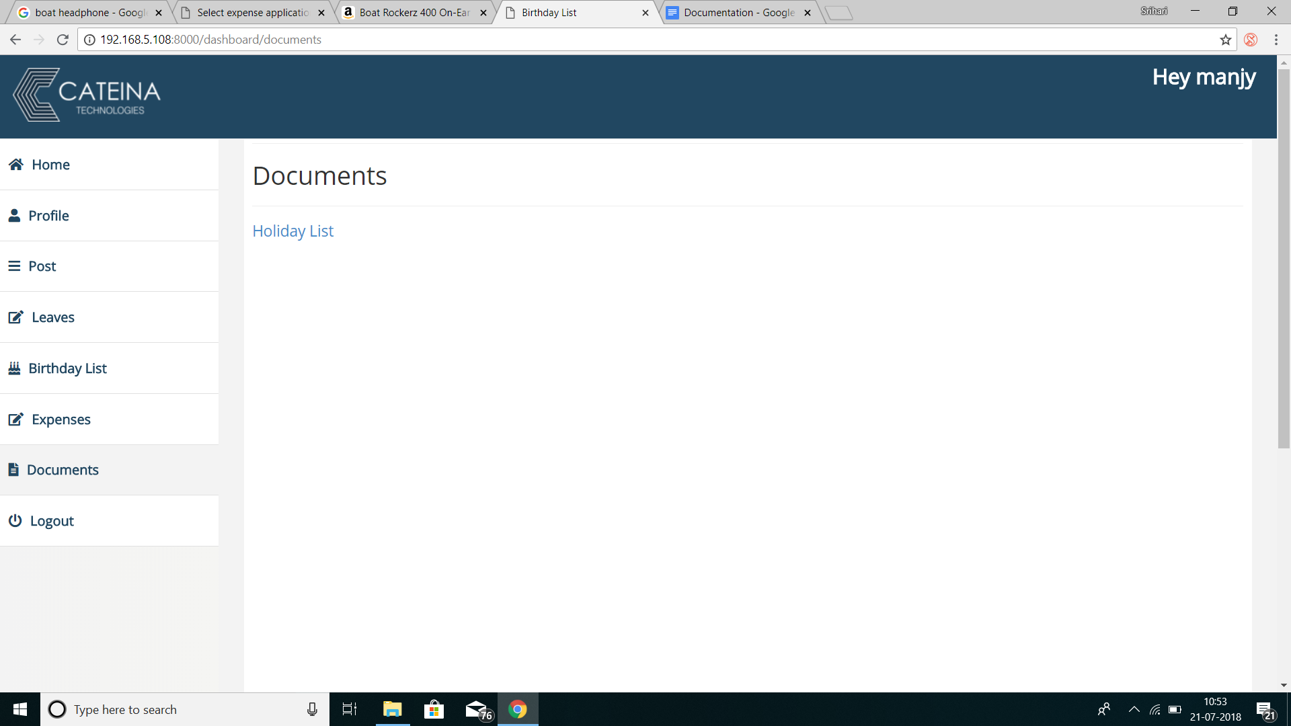

* Select the Documents option from the Dashboard
* On selecting it you will see this screen.
* All documents uploaded by the Admin can be seen on this page.
* Documents like Holiday List, Company Policies and other documents can be uploaded by the Admin.

**11.Home**

* On logging in you are directed to the Home page.
* On this page you will see Announcements which are added only by an Admin.
* This is the Home page screen.
* On logging in you are directed to the Home page.
* On this page you will see Announcements which are added only by an Admin.
* This is the Home page screen.

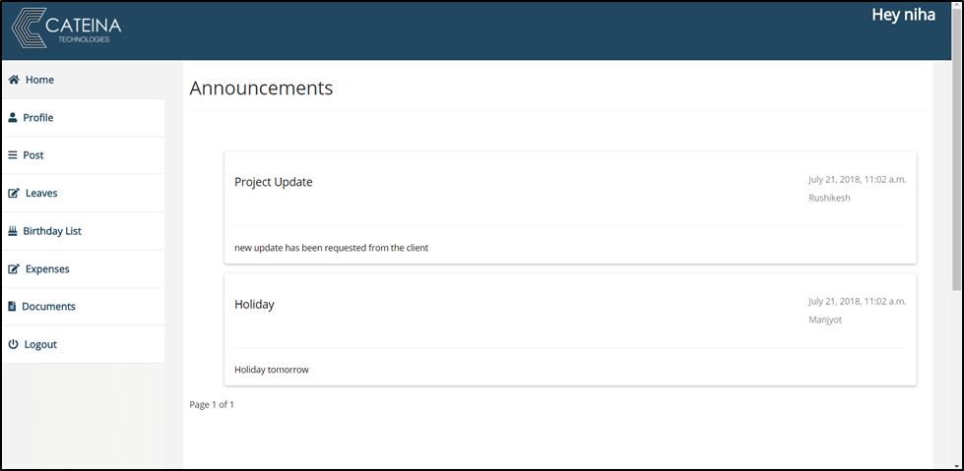

* On logging in you are directed to the Home page.
* On this page you will see Announcements which are added only by an Admin.
* This is the Home page screen.

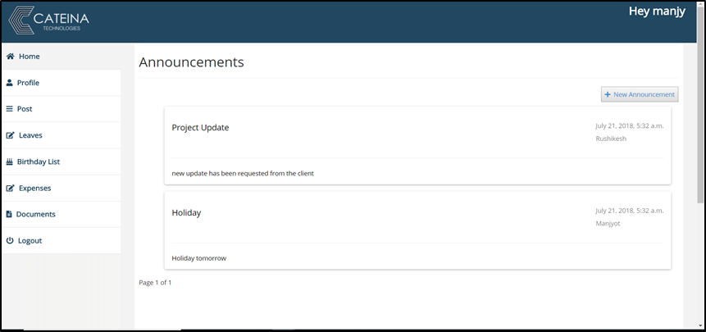

* Only to the Admins will a New Announcement button be available, for other users the can only see the Announcements.

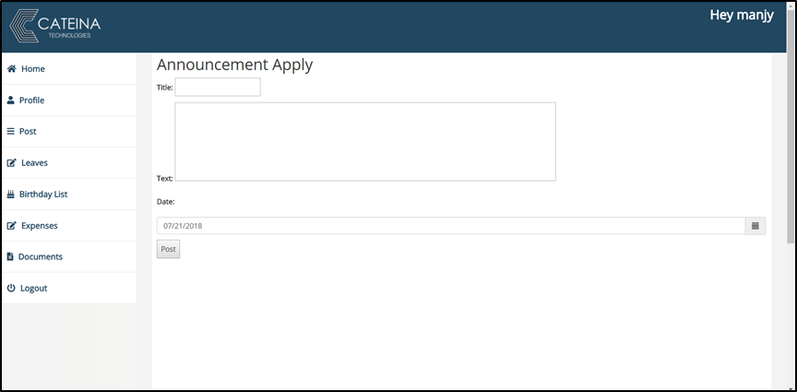

* On clicking the New Announcements button will be directed to this page.
* You will select the:
  + - * Title
      * Text
      * Date

and you click Submit.

* Doing this will register your Announcements which can now be seen on the home page by any user logging in.